MILTON KEYNES MARINA LIMITED
Milton Keynes Marina
Waterside
Peartree Bridge
Milton Keynes
MK6 3BX

GSA ATLANTA 24 – RIVER THAMES TRIAL DAY

Thank you for your interest in the Atlanta 24 at the London Boat Show. Together with GSA Marina we would like to invite you to a River Thames trial day just downstream of the Windsor Public Slipway at Stovell Rd, Windsor, SL4 5JB on 22nd January 2012. This is behind the Windsor Leisure Centre where there is a pay and display car park.

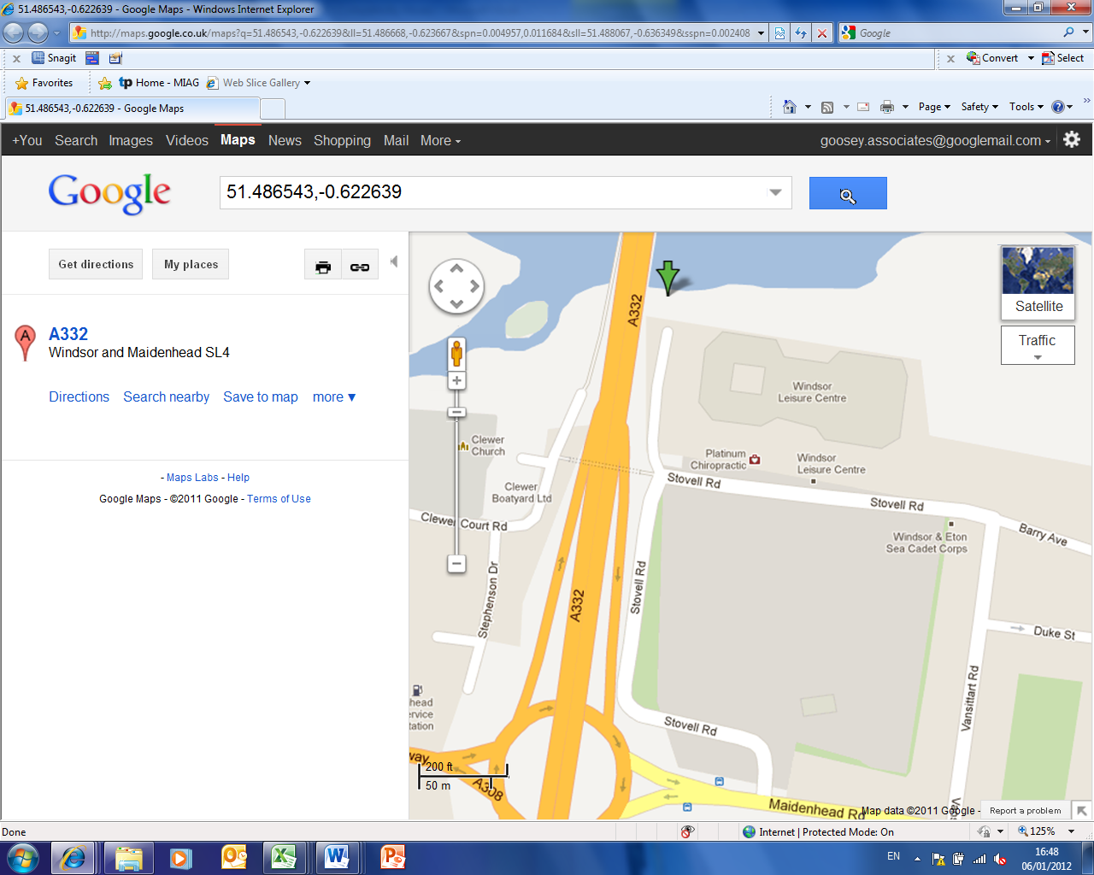

Atlanta 24 – designed for cruising our Rivers and Canals

If you have not already agreed a time with MK Marina or GSA Marine at the Boat Show, please call us on 01908 672672 (or email us at office@mkmarina.co.uk) to advise what time you would like to take her out between 10am and 4pm, or if you cannot make it, lets us know and we can discuss other dates.

